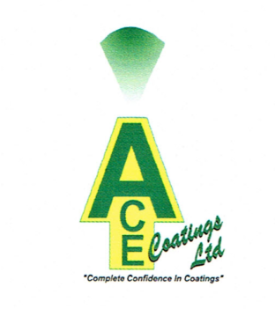

ACE TECHCOAT G4S PAINT

General Description

A Graphite Paint for coating surfaces to stop molten steel penetration and protect surrounding areas. Primarily used within the steel industry.
Also used as a lubricant and is subject to high temperatures to 2900c.

Physical Properties

 | Range | Typical
Carbon | 17-27% | 22.79
Na₂0 | 2% Max | 0.29
SiO₂ | 6% Max | 3.49
Al₂0₃ | 2% Max | 1.38
H₂0 | 68-79 % | 72 %

Surface Application

The Surface to be coated should be dry, sound and free from grease, oil dust and flaking paint etc.

Application

For Ace Techcoat G4S Paint apply with a brush. Can be applied to all types of Castables, Hinge mechanisms and chains, Ropes on cranes to prevent friction. Also used on slide gate mechanisms on the Tundishes and ladles and can be applied to the roof of the furnaces.

Uses

Companies such as, Forgemasters and Tata Steel are using this product and come with high recommendations.

Forgemasters say: ‘Graphite paint is currently used in the Melt Shop for coating steel fabrications that are subject to high temperatures, for example, heat shields and roof deltas.
The results have been successful with prevention of steel skull build up. This gives an extended life to these steel fabrications, cutting maintenance and replacement costs substantially.
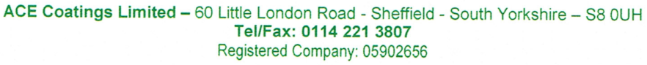

A typical heat shield costs approximately £9000 per item and roof deltas approx. £200 per item. We have found the graphite paint gives a 50-60% increase in the life of these items.
It is intended to trial this material in the Foundry where there are numerous possible uses as a coating.’

Tata Steel uses the product for the following uses:
- Used for sliding gate as a Lubricant
- Used for Alcar machine as lubricant between two refractory surfaces and where steel and moving parts interface
- Used on Rotary gate system on teeming ladle
- Used on Teeming ladle lids to prevent metal sticking to the refractory concrete
- Used on Torpedo ladles mouths for same purpose

Container

Available in various pack sizes from 1kg, 2.5kg, 5kg, 10kg and 25kg.

Cleaning

Tools may be cleaned with white spirit or paraffin.

Health & Safety

This is a Non- Hazardous material.

